Here’s a suggestion for a template to use to document each source of data you find:

**Source (Name)**:

* URL:
* Type(s) of Info Provided/Data Examined:
* Data Formatting:
* About Source:

EXAMPLE

**Source (Name)**: “Environmental and Health Impacts of Air Pollution: A Review” from *Frontiers in Public Health*

* URL: <https://www.ncbi.nlm.nih.gov/pmc/articles/PMC7044178/>
* Type(s) of Info Provided/Data Examined: Comprehensively reviews current information on sources/types of pollution and their effects; limited data provided for spatial mapping.
* Data Formatting: Textual, provides limited numerical data.
* About Source: Highly credible journal which publishes public health research.

### Lithium Brine Extraction Locations We Want to Map

* Shining: Thacker Pass
* Benjamin: Silver Peak
* Ashley: Salton Sea
* Alex: Great Salt Lake
* Gensheng: Jackpot Lake (near Las Vegas)

### Data We Want to Map

* 3D Visualization Ideas: Lithium ore, somehow visualizing brine resource vs. hard/soft rock resource extraction methods (we are focusing on brine extraction); 3D representations of particularly important data
* Health Data (rates of disease, vulnerability to diseases due to factors like pollution, access to healthcare services)
* Nature/Resource Data (data on access to food/water with special emphasis on (ground)water access, data on at-risk species)
* Socioeconomic Data (race, age, gender, and class data with special emphasis on Indigenous population data, average household income data)
* Labor Data (how would lithium mines be staffed, how would workers be paid, would they be unionized, etc.)
* Miscellaneous (historically unceded treaty land, where exactly a mine is situated within a given county and population concentrations in the county, mobility?)
* NOTE: It could be helpful to map out “controls” (i.e. communities somewhat nearby the mines) to show how the communities we’re mapping are at elevated risk of negative health impacts, for example.
* Also note Day 6.1 links for resources on GIS mapping.

### Benjamin’s Sources

**Source (Name)**: **Native Land Information System**

* URL: <https://data.nativeland.info/dataset>
* Type(s) of Info Provided/Data Examined: This website has 28 distinct datasets from which we could pull information, including a database of recognized tribal land ownership by state, Indigenous economic statuses, agricultural info, and other general info.
* Data Formatting: CSVs as well as PDFs and other file formats.
* About Source: Reputable source, pulls datasets from other reputable sources. 20+ year old organization founded by Indigenous folks. Quote from [website](https://nativeland.info/about/history/): “The Native Lands Advocacy Project and Native Land Information System is the product of nearly 20 years of grassroots organizing and advocacy work with a track record of impactful data-driven support to Native organizations, and led by the belief that the colonial status quo can be challenged.”

**Source (Name)**: **Western U.S. Lithium**

* URL: <https://www.google.com/maps/d/u/0/viewer?mid=1kq8TRUSMR97kg-XQ22kdQpE4lUT0Rj49&ll=38.27493251229276%2C-111.50454879999998&z=5>
* Type(s) of Info Provided/Data Examined: Locations of lithium mines and water sources in the Western U.S. Importantly, this map also includes color coding to indicate the maturity of any given project. Thus, if we choose to analyze projects that are under permitting review exclusively, for example, we could use this map for that purpose.
* Data Formatting: Landmarks on a Google Map; I imagine there’s some way to extract the exact coordinates but more research/work would need to be done to translate their points to mappable 2D spacers we could visualize.
* About Source: User-created Google Maps compendium, supported by Patrick Donnelly of the Center for Biological Diversity, a 501(c)(3) principally located in Tucson but with satellite operations across the US and one office in Mexico.

**Source (Name)**: **Climate and Economic Justice Screening Tool**

* URL: <https://screeningtool.geoplatform.gov/en#3/33.47/-97.5>
* Type(s) of Info Provided/Data Examined: Data on each American county/territory related to burdens on communities from climate change, energy, health, housing, legacy pollution, transportation, (waste)water, and workforce development.
* Data Formatting: CSV, Shapefile (especially helpful for GIS!)
* About Source: Tool created via Executive Order from Pres. Biden to mandate that the Council on Environmental Quality map particular kinds of burdens (e.g. climate, health) and use that to inform federal policy/spending.

**Source (Name)**: **Developments in the Theory and Practice of Cybercartography: Applications and Indigenous Mapping**

* URL: <https://books.google.com/books?hl=en&lr=&id=FYF5AAAAQBAJ&oi=fnd&pg=PP1&ots=HzIWzArtGJ&sig=3yN-ifFxRfdkGekvEv-FlCeKY6s#v=onepage&q&f=false>
* Type(s) of Info Provided/Data Examined: Provides information on the state-of-the-art in cybercartography (i.e. the study and use of digital mapping tools) as well as its applications to issues concerning Indigenous populations worldwide.
* Data Formatting: N/A, this is a guidebook.
* About Source: Book created to address the most pressing issues related to cybercartography and how they can be leveraged for the benefit of Indigenous peoples. Also has helpful descriptions and guides on how to use tools such as A/V integration in GIS, the use of opacity, and inclusivity in the practice of cartography.

### 

### Alex's Sources

**Source (Name)**:

* URL: <https://www.sltrib.com/news/environment/2023/11/09/compass-minerals-halt-great-salt/>
* Type(s) of Info Provided/Data Examined: This article by the Salt Lake Tribune highlights the concerns when extracting lithium from the Great Salt Lake by conventional means. The lake is ready at its smallest ever due to the massive drought, and the plans by Compass Minerals would have required a huge amount of not just brine from the lake, but also treated water that would have to be pumped from other places.
* Data Formatting: Article with text
* About Source: The Salt Lake Tribune describes itself as "Utah's independent nonprofit news source covers news, politics, faith, arts and sports for Salt Lake City and Utah." Headquartered in Salt Lake City, "it was founded in 1871 and was known as Mormon Tribune", according to Wikipedia.

**Source (Name)**:

* URL:

<https://lilacsolutions.com/2024/02/with-145m-in-fresh-capital-were-building-the-foundation-of-a-u-s-lithium-supply-chain/>

* Type(s) of Info Provided/Data Examined: This information comes from a startup, Lilac, that wants to harvest the lithium in the Great Salt Lake. They have developed a new, far superior method to extract lithium from brine, that is much more versatile and effective than existing methods, and that also consumes much less water. They talk about how their method is already proven to work, and how it wastes much less lithium and consumes much less of the Great Salt Lake's precious water.
* Data Formatting: Article with text
* About Source: The source is written in first person by the CEO himself. "Lilac Solutions is a lithium extraction technology company based in Oakland, California. Lilac has developed a patented ion exchange technology that facilitates production of lithium from brine resources with high efficiency, minimal cost, and ultra-low environmental footprint. Lilac’s mission is to scale global lithium production to support the electric vehicle industry and energy transition."

**Source (Name)**:

* URL:
* <https://www.wsj.com/science/environment/great-salt-lake-lithium-startup-lilac-d84c9f76>
* <https://humanprogress.org/the-great-salt-lake-is-full-of-lithium-a-startup-wants-to-harvest-it/>
* Type(s) of Info Provided/Data Examined:
* Data Formatting: Article with text
* About Source:

**Source (Name)**:

* URL: <https://www.sltrib.com/news/environment/2024/02/09/mineral-companies-use-7-great-salt/>
* Type(s) of Info Provided/Data Examined:
* Data Formatting: Article with text
* About Source:

**Source (Name)**:

* URL: <https://townlift.com/2024/02/lithium-mining-at-the-great-salt-lake/>
* Type(s) of Info Provided/Data Examined: 85000 acres statistics
* Data Formatting: Article with text
* About Source:

**Source (Name)**:

* URL: <https://www.businessinsider.com/great-salt-lake-lithium-startup-key-to-green-energy-future-2024-2>
* Type(s) of Info Provided/Data Examined:
* Data Formatting: Article with text
* About Source:

**Source (Name)**:

* URL: <https://projectblue.com/blue/news-analysis/769/great-salt-lake-mineral-extraction-bill-passed-by-utah-house-committee>
* Type(s) of Info Provided/Data Examined:
* Data Formatting: Article with text
* About Source:

**Source (Name)**:

* URL: <https://www.sltrib.com/news/environment/2023/09/07/new-lithium-company-wants-billions/>
* Type(s) of Info Provided/Data Examined:
* Data Formatting: Article with text
* About Source:

**Source (Name)**:

* URL: <https://www.utahbusiness.com/what-to-do-about-the-great-salt-lake-drying-up/>
* Type(s) of Info Provided/Data Examined:
* Data Formatting: Article with text
* About Source:

**Source (Name)**:

* URL: <https://extension.usu.edu/irrigation/research/agricultural-water-use-salt-lake-basin>
* Type(s) of Info Provided/Data Examined:
* Data Formatting: Article with text
* About Source:

[**https://pws.byu.edu/great-salt-lake**](https://pws.byu.edu/great-salt-lake)

[**https://climate.usu.edu/GSL.php**](https://climate.usu.edu/GSL.php)

[**https://wildlife.utah.gov/gslep/about/water-levels.html**](https://wildlife.utah.gov/gslep/about/water-levels.html#:~:text=The%20lake%20has%20gone%20through,square%20miles%20of%20surface%20area)

[**https://www.usgs.gov/media/before-after/great-salt-lake-comparison-1986-and-2022**](https://www.usgs.gov/media/before-after/great-salt-lake-comparison-1986-and-2022)

Lithium in energy:

<https://energyx.com/blog/what-is-lithium-used-for-in-renewable-energy/>

<https://pubs.usgs.gov/fs/2014/3035/pdf/fs2014-3035.pdf>

<https://www.energy.gov/eere/geothermal/lithium>

<https://theconversation.com/lithium-is-finite-but-clean-technology-relies-on-such-non-renewable-resources-109630>

<https://www.visualcapitalist.com/sp/tomorrows-lithium-demands/>

Geothermal lithium:

<https://www.energy.gov/eere/geothermal/articles/can-geothermal-energy-solve-lithium-shortfall>

<https://www.energy.ca.gov/publications/2020/selective-recovery-lithium-geothermal-brines>

<https://www.sciencedirect.com/science/article/pii/S2666792423000276>

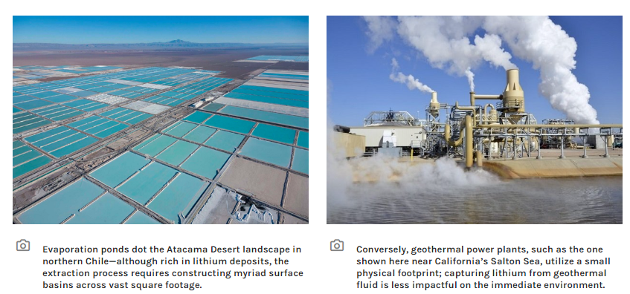

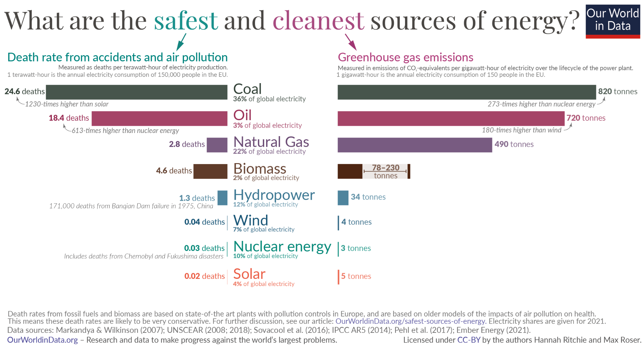

<https://ourworldindata.org/safest-sources-of-energy>

<https://bendingbranches.com/blogs/resources/kayaking-on-great-salt-lake-utah>

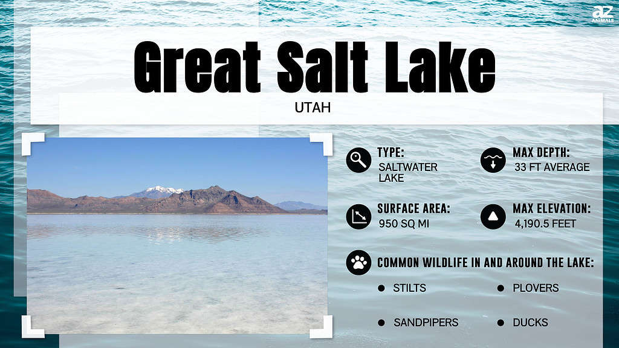

**Outdated:**

**Source (Name)**:

* URL: <https://www.theguardian.com/us-news/2022/oct/18/lithium-mining-nevada-boom-car-battery-us-climate-crisis>
* Type(s) of Info Provided/Data Examined: A short article that gives a brief overview of lithium extraction and why it's controversial.
* Data Formatting: Article
* About Source: Article by The Guardian from a year and a half ago, likely inspired by the Thacker Pass lithium mine project

**Source (Name)**:

* URL: <https://www.dw.com/en/us-has-huge-lithium-reserves-but-concerns-mount-over-mining/a-64103024>
* Type(s) of Info Provided/Data Examined:
* Data Formatting: Article
* About Source: Article by "dw.com"

**Source (Name)**:

* URL: <https://insideclimatenews.org/news/07112021/lithium-mining-thacker-pass-nevada-electric-vehicles-climate/>
* Type(s) of Info Provided/Data Examined:
* Data Formatting: Article
* About Source:

**Source (Name)**:

* URL: <https://www.npr.org/2023/01/06/1147452848/the-fate-of-americas-largest-lithium-mine-is-in-a-federal-judges-hands>
* Type(s) of Info Provided/Data Examined:
* Data Formatting: Article
* About Source:

**Source (Name)**:

* URL:

<https://time.com/6294818/lithium-mining-us-maine/>

* Type(s) of Info Provided/Data Examined:
* Data Formatting: Article
* About Source:

### 

### Shining ’s Sources

**Source (Name)**: **Interdependencies of lithium mining and communities sustainability in Salar de Atacama, Chile**

* URL: <https://doi.org/10.1016/j.jclepro.2020.120838>
* Type(s) of Info Provided/Data Examined: graphical information of mining location and their impacts
* Data Formatting: GIS graphics and data
* About Source: Demand for clean technologies has increased global lithium (Li) production. However, the potential impacts of lithium extraction, especially on frontline communities, have not been studied holistically. This research assesses the community sustainability in Salar de Atacama, Chile. We developed a coupled natural-social systems framework to analyze the interdependencies of the lithium extraction and its impacts. Using data from the Chilean census, company sustainability reports, remote sensing, and media archives, we investigate the temporal dynamics of water availability, labor influx, employment, social activism, and [corporate social responsibility](https://www.sciencedirect.com/topics/earth-and-planetary-sciences/corporate-social-responsibility). Our study finds that between 2002 and 2017, the total water storage declined at a rate of 1.16 mm/year. Compared to other uses, water consumption from Li-mining was higher by two orders of magnitude. Mining played a crucial role in creating greater migration impacts, as indicated in a high migration effectiveness index of 85% and 90%, respectively. Labor influx increased 2.3 times, whereas the role of local labor in mining decreased from 52% to 18%. Local social activism increased both in intensity and scale. Our [interdependency](https://www.sciencedirect.com/topics/engineering/interdependency) framework and analyses show that Li-mining and local communities are closely linked at both local and regional scale through the sharing of water resources, economic opportunities, and resource governance.

**Source (Name)**: **What do frontline communities want to know about lithium extraction? Identifying research areas to support environmental justice in Lithium Valley, California**

* URL: <https://doi.org/10.1016/j.erss.2023.103043>
* Type(s) of Info Provided/Data Examined:
* Data Formatting: Statistical graphics
* About Source: Clean energy technologies provide global benefits through climate mitigation and many local environmental benefits for consumers. However, the supply chains that produce them inevitably impose some environmental burden on the communities where they operate. To align with the principles of environmental justice, the burdens and benefits of clean energy supply chains should be distributed equitably, with decision-making processes that empower local communities to participate. Academic research can play a key role as a source of transparent information that addresses the concerns of frontline communities; however, this requires deliberate effort during the initial stages of research to understand what those concerns are and seek data that will respond to them. As a case study, this article analyzes public meetings about a developing lithium industry in Imperial, California, and reviews relevant literature to build a research agenda that is guided by the priorities of local stakeholders. We find that water consumption, public health impacts, local employment, and opportunities to participate are high-priority topics for community members. We also compare the content of discussions across groups, finding that participants in community-focused meetings mainly asked about the local impacts of the process, whereas state-led discussions focused on the sustainability of direct lithium extraction compared to conventional production methods. To address the priorities of frontline communities, we recommend evaluating water consumption in the context of regional availability, including local air emissions and waste streams in sustainability analyses, and monitoring the impact on local employment over time to ensure the promises made during development accrue to communities.

### 

### Ashley’s Sources - Salton Sea

EXAMPLE

**Source (Name)**: “Environmental and Health Impacts of Air Pollution: A Review” from *Frontiers in Public Health*

* URL: <https://www.ncbi.nlm.nih.gov/pmc/articles/PMC7044178/>
* Type(s) of Info Provided/Data Examined: Comprehensively reviews current information on sources/types of pollution and their effects; limited data provided for spatial mapping.
* Data Formatting: Textual, provides limited numerical data.
* About Source: Highly credible journal which publishes public health research.

**Source (Name)**:

* URL: <https://earthworks.org/releases/lithium-valley/#:~:text=SALTON%20SEA%20DEGRADATION%3A%20The%20Salton,issue%20and%20compromising%20restoration%20efforts>.
* Type(s) of Info Provided/Data Examined: Information on negative impacts on environment - no visual data for mapping
* Data Formatting: article
* About Source:
* AIR QUALITY: Construction and operation of lithium and geothermal facilities in Imperial Valley may impact already degraded air quality through emissions of particulate matter, greenhouse gases, and hydrogen chloride.
* FRESHWATER CONSUMPTION: Lithium extraction projects will consume Colorado River water for cooling and processing. If the lithium industry expands to its planned capacity, it will exceed the freshwater currently allocated by the Imperial Irrigation District for non-agricultural use.
* SALTON SEA DEGRADATION: The Salton Sea is rapidly shrinking, exposing harmful dust contaminated by pesticides and fertilizers. If water is diverted from agriculture to lithium production, it may speed up the shrinking of the Sea, exacerbating the air quality issue and compromising restoration efforts.
* HAZARDOUS WASTE AND MATERIALS: The direct lithium extraction process will produce hazardous byproducts harmful to human health, such as arsenic, lead, and cadmium, that must be safely disposed of.
* SEISMIC ACTIVITY: While lithium extraction itself is unlikely to have an impact on earthquake risk in this seismically active area, further geothermal development might.

**Source (Name)**:

* URL: <https://nevadacurrent.com/2023/11/29/salton-sea-could-meet-nations-lithium-demand-for-decades-study-finds/#:~:text=The%20Salton%20Sea%20is%20believed,pit%20mining%20or%20evaporation%20ponds>.
* Type(s) of Info Provided/Data Examined: some mapping information, mainly numerical stats.
* Data Formatting: article/ text
* About Source:
* The Salton Sea is believed to have the highest concentration of lithium, contained in geothermal brines, in the world.
* The Salton Sea is believed to have the highest concentration of lithium, contained in geothermal brines, in the world.Lithium extraction in the Salton Sea may represent a rare consensus among conservationists, local populations, and industry, as mining projects face substantial community concern and backlash in Nevada and other parts of the country.
* In Nevada, several Native American tribes have filed lawsuits against the proposed Thacker Pass mine, arguing the [mine would desecrate a sacred site and violate](https://www.nevadacurrent.com/2023/11/21/judge-again-rules-against-tribes-effort-to-stop-lithium-mine/) federal preservation law and land policy.
* Conservation groups have also fiercely opposed a planned lithium mine at Rhyolite Ridge in Esmeralda County, overlapping the only known population of the Tiehm’s buckwheat plant, a rare wildflower [listed as endangered](https://www.nevadacurrent.com/2022/12/14/feds-list-rare-nv-wildflower-tiehms-buckwheat-as-endangered/) by the U.S Fish and Wildlife Service last year.
* Three companies — Berkshire Hathaway Energy, EnergySource, and Controlled Thermal Resources — have been working for years on plans to extract lithium by taking advantage of the Salton Sea’s rich geothermal resources.
* Residents of Niland, California — the closest community to a geothermal plant — said they believed a combined lithium extraction and geothermal energy production facility would have a positive impact on the local community, with slightly higher scores for geothermal compared to lithium extraction, according to a survey conducted by the DOE. However, surrounding communities in additional surveys did express concern about environmental impacts and air quality.
* vaporating water levels and warming of water temperatures.
* <https://insideclimatenews.org/news/26082023/salton-sea-lithium-mining-california/>

Rhino sig up for 3D images on google map and Sketchfab

* 3D Visualization Ideas: Lithium ore, somehow visualizing brine resource vs. hard/soft rock resource extraction methods (we are focusing on brine extraction); 3D representations of particularly important data
* Health Data (rates of disease, vulnerability to diseases due to factors like pollution, access to healthcare services)
* Nature/Resource Data (data on access to food/water with special emphasis on (ground)water access, data on at-risk species)
* Socioeconomic Data (race, age, gender, and class data with special emphasis on Indigenous population data, average household income data)
* Labor Data (how would lithium mines be staffed, how would workers be paid, would they be unionized, etc.)
* Miscellaneous (historically unceded treaty land, where exactly a mine is situated within a given county and population concentrations in the county, mobility?)
* NOTE: It could be helpful to map out “controls” (i.e. communities somewhat nearby the mines) to show how the communities we’re mapping are at elevated risk of negative health impacts, for example.

### 

### Gensheng’s Sources

**Source (Name)**: jackpot lake lithium brine project

* URL: https://usharesources.com/projects/jackpot-lake/
* Type(s) of Info Provided/Data Examined: mapping information
* Data Formatting: Article
* About Source: This site presents some basic information about the jackpot lake lithium project, describes how the lithium brine is formed and some important data about lithium, such as concentration and utilization, as well as providing a model of the basin.

**Source (Name)**: In remote Nevada valley, race for more lithium comes down to water

* URL: https://thenevadaindependent.com/article/in-remote-nevada-valley-a-race-for-more-lithium-comes-down-to-waterefbfbc
* Type(s) of Info Provided/Data Examined:information on waiter impact the project
* Data Formatting: article
* About Source: A short description of the importance of water resources for lithium mining and extraction, even within Nevada has some legal issues

**Source (Name)**: American battery technology company announces start of operations at its commercial scale, lithium-lon battery recycling facility in Nevada

URL: https://www.prnewswire.com/news-releases/american-battery-technology-company-announces-start-of-operations-at-its-commercial-scale-lithium-ion-battery-recycling-facility-in-nevada-301953607.html

* Type(s) of Info Provided/Data Examined:information about lithium reclying
* Data Formatting: article
* About Source: ABTC took the lithium technology and started commercializing it and opened a super plant in Nevada. The chain will be low-cost, environmentally friendly and forward-looking.